Automated ML Pipelines & Model Serving
Abby Romano
OIM3641

Dataset: I used the UCI Machine Learning Repository “Adult Income” dataset. It contains over 30,000 rows of data and includes both categorical and numerical features. I chose the target variable to be income and classified as either over or under 50k.

PyCaret Model Comparison
PyCaret was used to compare the different classification models as shown below. Light GBM was the top performing model based on the data presented below.

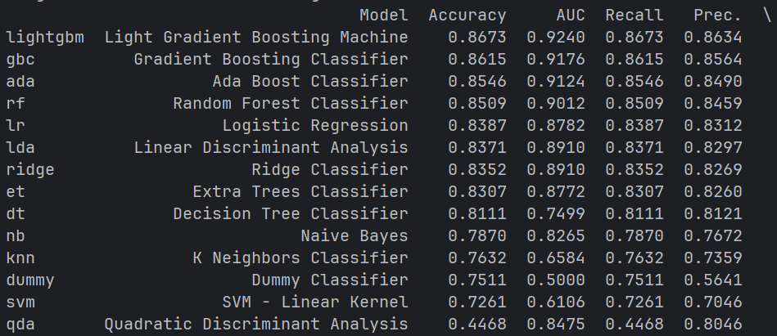

FastAPI Model Serving
The model is turned into a website using FastAPI. I tested by sending sample data is JSON format, and it successfully returned a prediction.

‘